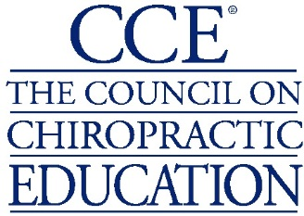

COUNCIL EXECUTIVE COMMITTEE (CEC)
ELECTION ANNOUNCEMENT

February 4, 2020

The Council on Chiropractic Education (CCE) is pleased to announce the 2020-2022 Council Executive Committee (CEC) election results. The elected Councilors’ service began following the January 2020 annual meeting. Please join us in congratulating the following individuals.

Council Chair
Jean-Nicolas Poirier, D.C., Ed.D.
Dean of the School of Health Sciences and Education
New York Chiropractic College

Associate Chair
S. Steven Baker, D.C.
Private Practitioner
Tucson, Arizona

Treasurer
Susan Wenberg, D.C.
Staff Chiropractor, VA Medical Center
Tucson, Arizona

Councilor-At-Large
Kristina L. Petrocco-Napuli, D.C.
Director of Assessment and Accreditation
Logan University – College of Chiropractic

