Instructional Guide for Attachments, Hyperlinks, and PDF

A typical self-study report often has more than 150 attachments, presented as artifacts and evidence to support the narrative of a self-study report, which is organized into sections/chapters for each Standard (e.g. Standards A-K). Given the volume of information that is presented in a self-study report it is important that this document is well organized for readability and ease of use for the site team and the Council, who are evaluating the program. Prior to linking attachments in the self-study consider these helpful tips in organizing the attachments.

Tips for ease of use and readability:

Tip 1: Organize and name the attachments files in a manner that is easy for the external reader to locate in the attachments folder, if a hyperlink doesn’t work. In the examples below, the file naming system follows the self-study report chapters or Standard-sections. (Note: using zeros in single digits ensures the files stay in numerical order when listed both alphabetically and numerically.)
- A01 DCP Mission Statement
- A02 University Catalog
- A03 DCP Strategic Plan
- A15 Program Effectiveness Plan
- A16 Program Effectiveness Data AY2016-17
- D01 Financial statement 2016-17
- G01 Admissions Requirements
- H12 Curriculum Map
- H18 Clinical Assessment Methods
- H20 MC Outcomes Data – Tri 10 Spring 2017

Tip 2: Provide a list of attachments at the end of each section or chapter of the self-study. This allows the reader to quickly see which documents are provided as evidence for the Standard.

Tip 3: If the attachment is an excerpt from a larger document, identify the title of the larger document in a cover page, header or footer. This allows the reader to quickly identify what document the excerpt was taken from, e.g. an ethics policy excerpted from the Student Handbook vs. Clinic Manual vs. an Employee Policy Handbook.

Tip 4: Do not create hyperlinks to intranet pages that require a log-in. These hyperlinks will not open for an external reader. However, the program may link to a pdf copy of these pages, for example, to demonstrate that a document or information is available to all faculty via a faculty accessible intranet page.

There are several ways to attach or hyperlink documents to a self-study report depending on the Adobe Acrobat products that are used. This guide provides examples if you using Adobe Acrobat Pro or Abode Acrobat Reader.

- Self-study report with an “Attachments” folder 3
  - Create a linked file in a PDF document via Adobe Acrobat Pro 3

b1. Create hyperlinks in a Word document 6
b2. Convert a Word document to PDF via Adobe Acrobat Reader 8

- Self-study report with self-contained attachments via Adobe Pro 9
  - Add attachments into Adobe Pro 9
  - Link to the Attached PDF Documents 10
  - Attach an Excel or Word Document 11
  - Create a Website Hyperlink 12

I. Self-study Report with “Attachments” folder

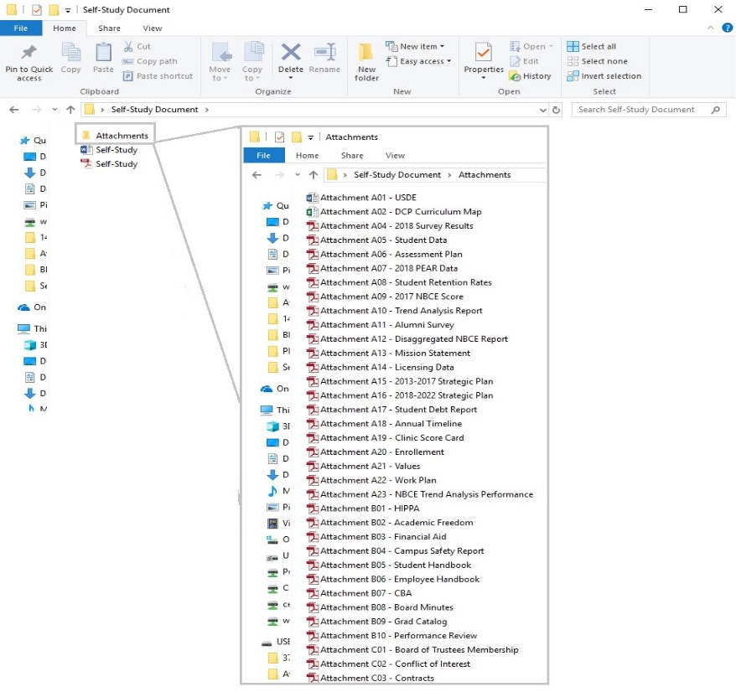
  - Create a Linked File in Acrobat Pro

- Once the PDF document is created click on the “Tools” options found at the top left of the window.
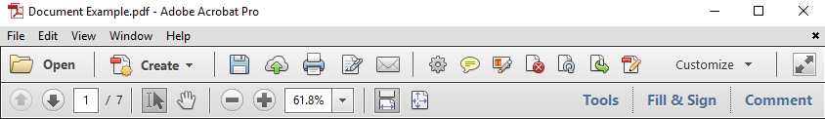

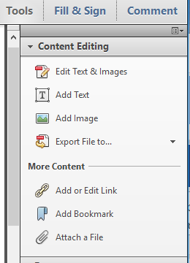
- Then click on the arrow next to the “Content Editing” option, and click the “Add or Edit Link” function in from the drop down.

- The pointer becomes a cross hair, and any existing links in the document, including invisible links, are temporarily visible. Drag a rectangle where you want to create a link.

- In the “Create Link” pop up window choose the “Open a file” radio button, then click “Next” button. (Preferences, such as link visibility, color, etc., is set in this window as well.)

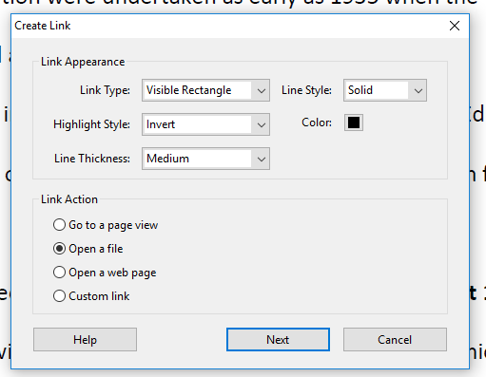

- A “Select File to Open” window will open, choose the document which will open when the link is clicked, then click the “Open” button.
(Please be sure the document chosen is in the same folder as the self-study. In this example, the working PDF is saved on “C:” drive and all of the documents being linked are a file called “Exhibits,” also on the “C:” drive.)

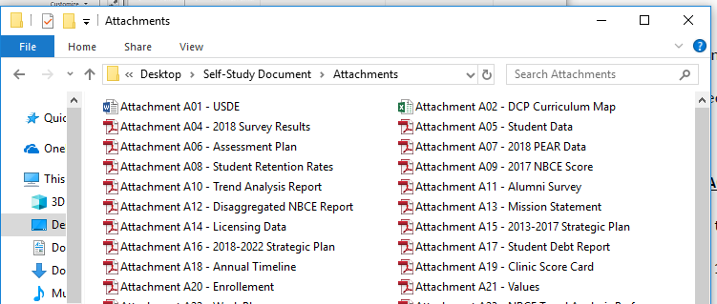

- If the document being linked is a PDF, a “Specify Open Preference” window will open. Chose the “New window” radio button, and then click the “OK” button.
(This ensures a new window is opened on the end product, no matter what the user’s preference is set as on another computer.)

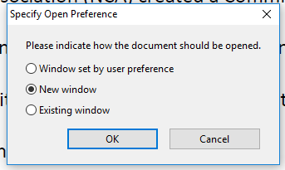

- A box is created around the selected words and can be manipulated at this time using the directional boxes and the link has been established. (NOTE: This link will be broken if the file is moved to a different location or if the target location file name is changed.) 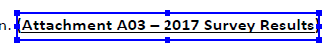

b1. Create Hyperlinks in a Word Document:

In this example, create hyperlinks in a Word document, then convert the Word document into pdf format using Adobe Reader.

1. In the Word document, select the text that you will insert a hyperlink in; then under the INSERT tab, choose Hyperlink. Alternatively, you may right click the mouse to bring up a drop box and select Hyperlink.
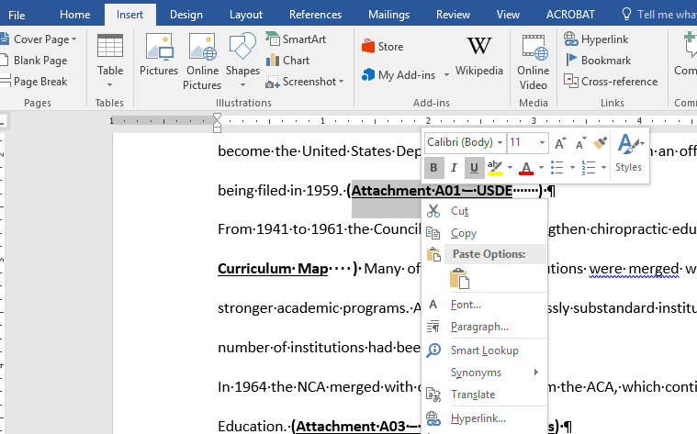

2. Then find and select the file to hyperlink. When you double-click on the file its target location will appear in the Address box. Note, if you are hyperlinking to a URL address, copy and paste the URL address into the Address box.
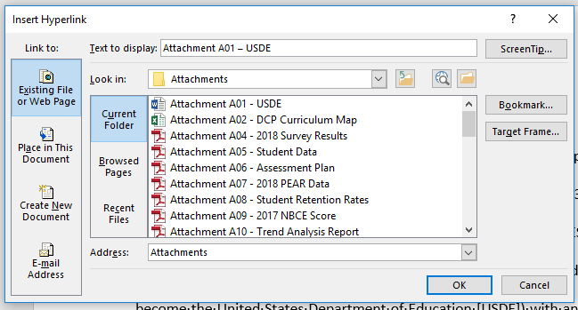

2. Before selecting OK, open the Target Frame on the right side, and select New Window. Then select OK on the Set Target Frame window and then select OK in the Insert Hyperlink window. The hyperlink is complete. The target frame function sets the hyperlinked document to open as a new window, so it doesn’t replace the page with self-study narrative.

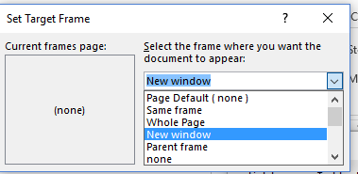

b2. Convert a Word document to PDF with Adobe Acrobat Reader:

Once all the hyperlinks are created in the self-study report you are ready to convert the Word document into pdf. Using the Save As functions, save the file as a pdf: Save As, then select PDF in the drop list (instead of saving as a Word file), as show below.
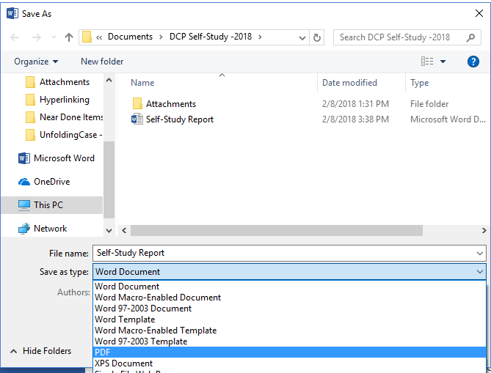

Tips when using the above method to create hyperlinked attachments:

Tip 1: Create an Attachments folder for all the documents that will be hyperlinked in the Self-study. Create this Attachments folder in the same folder where the Self-study narrative document is housed. Having the narrative report and the Attachments folder housed in the same “Self-Study” folder will allow you to easily move or copy the Self-study and the attachments without breaking the links.

Tip 2: Work from the C drive on your computer. Hyperlinks do not always open correctly if the link was created while working from a thumb drive, as it will create a target location file name that begin with E or F, etc.

II. Self-study report with self-contained attachments via Adobe Pro:

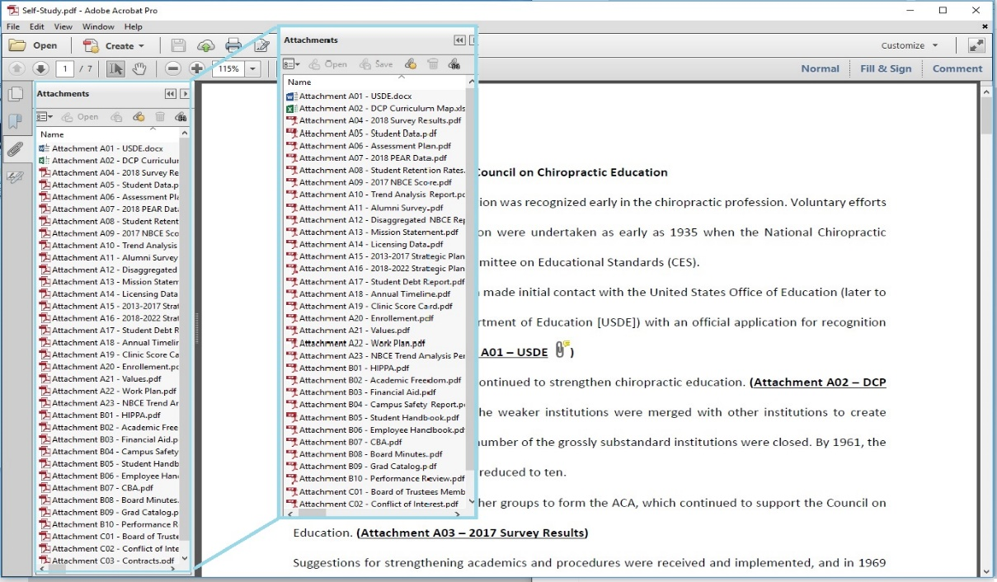
a. Add Attachments into Adobe Pro
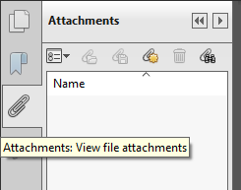
- Once the self-study has been made a PDF, click on the “Attachments” button (paper clip icon) on the left-hand side of the document window.

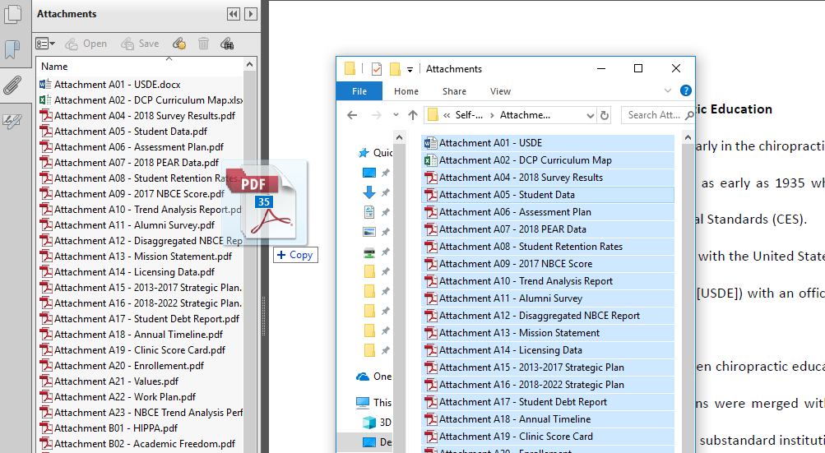
- Then drag and drop the documents being used as exhibits into the Attachments window below the word “Name.” (Be sure the name of the attachments are the names used to identify them throughout the self-study.)

- The attachments can be rearranged by clicking the up arrow next to “Name.” (Note: When numbering the attachments it is best to use zeros before single digits to ensure the attachments are in numerical order.)
b. Link to the Attached PDF Documents
- Once the attachments have been added to the PDF, click on the “Tools” options found at the top left of the window.

- Then click on the arrow next to the “Content Editing” option, and click the “Add or Edit Link” function in from the drop down.

- The pointer becomes a cross hair, and any existing links in the document, including invisible links, are temporarily visible. Drag a rectangle where you want to create a link.

- In the “Create Link” pop up window choose the “Go to page view” radio button, then click “Next” button. (Preferences, such as link visibility, color, etc., are set in this window as well.)
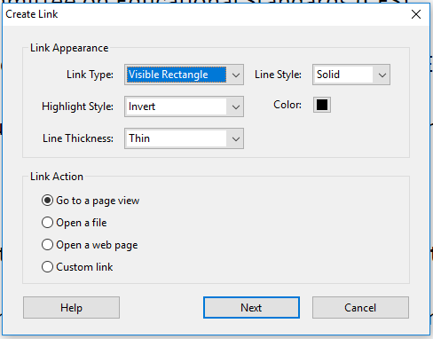

- The “Create Go to View” pop up window will open. Double click on the attachment in Attachments window, to open it.
- Then click the “Set link” button in the “Create Go to View” pop up window.
- A box is created around the selected words and can be manipulated at this time using the directional boxes and the link has be established.

c. Attach an Excel or Word Document:
- Once the attachments have been added to the PDF, click on the “Tools” options found at the top left of the window.

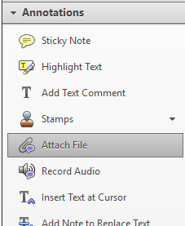
- Then click on the arrow next to the “Annotations” function, and click the “Attach File” function in from the drop down.

- The mouse pointer will turn into a thumbtack shape. Click next to the labeling of the attachment and an “Add File” pop up window will open. Navigate to the document you want, click on the document then click on the Open button.
- A “File attachment Properties” pop up window will open. Choose your properties then click the OK button. A paperclip (or icon of choosing) will appear in the location you chose to pin the file. This icon can be moved at this time to line it up with the attachment label, also, it can be double clicked to open the attached document.
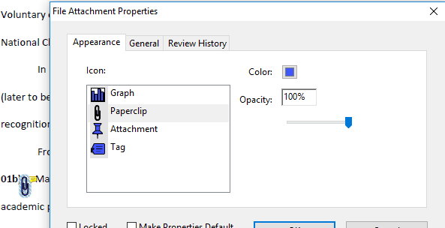

d. Create a Website Hyperlink:
- Click on the “Tools” options found at the top left of the window.

- Then click on the arrow next to the “Content Editing” option, and click the “Add or Edit Link” function in from the drop down.

- The pointer becomes a cross hair, and any existing links in the document, including invisible links, are temporarily visible. Drag a rectangle where you want to create a link.

- In the “Create Link” pop up window choose the “Go to page view” radio button, then click “Next” button. (Preferences, such as link visibility, color, etc., are set in this window as well.) 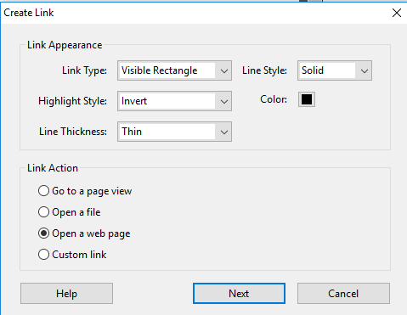
- An “Edit URL” pop up window will open. Type the URL then click the OK button. 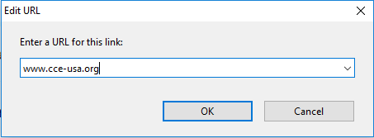
- A box is created around the selected words and can be manipulated at this time using the directional boxes and the link has be established.

